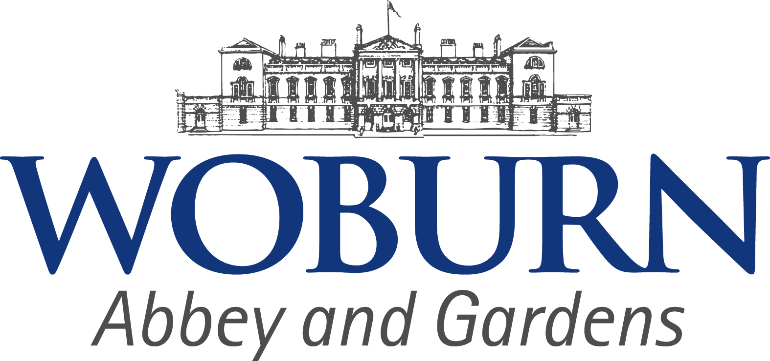

I would like to invite you and/or a colleague to come to Woburn Abbey and Gardens for a complimentary visit; to experience all that the Woburn Estate has to offer and to allow you to advertise our venue with confidence.

Aware that familiarisation events cannot always fit in with the industry’s varying busy periods, I hope that you are now able to schedule a visit to suit you. Just present this card on arrival to Woburn Abbey and Gardens and explore the House and Gardens in your own time.

I would however love the opportunity to meet you during your visit and share with you all that I do to look after groups visiting us. Please do contact me to arrange a mutually convenient visit date; we can then chat over a cup of tea or coffee and a piece of cake.

I do hope to meet with you in the near future.

Lisa Weaver

Groups Co-ordinator

[lisa.weaver@woburn.co.uk](mailto:lisa.weaver@woburn.co.uk)

01525 292101

Offer valid 10th April 2017 – 29th October 2017 for up to two adults.

Excludes Bank Holidays and 24th, 25th June 2017